Tables
Table 1: Characteristics of patients admitted for TLE with or without ATL from 1990 to 2008
 |  | Received ATL | Did not receive ATL | Odds Ratio (95% CI), or Student’s t (P value)
Age, mean (SEM), y |  | 30.84 ± 0.39 | 32.04 ± 0.13 | 2.25 (< 0.001)ª
Sex, n (%) | Male | 2,944 (5.6) | 49,375 (94.4) | 1 [Reference]
 | Female | 3,280 (5.7) | 53,985 (94.3) | 1.02 (0.97 – 1.07)
Race, n (%) | White | 3,710 (6.1) | 57,007 (93.9) | 1 [Reference]
 | Black | 221 (2.8) | 7,654 (97.2) | 0.44 (0.39 – 0.51)ª
 | Hispanic | 408 (5.7) | 6,792 (94.3) | 0.92 (0.83 – 1.03)
 | Asian/Pacific Islander | 46 (4.2) | 1,059 (95.8) | 0.67 (0.50 – 0.90)ª
 | Other or unknown | 2,193 (6.4) | 31,937 (93.6) | 1.06 (1.00 – 1.11)
Income, n (%) | 1st quartile | 1,068 (4.9) | 20,513 (95.1) | 1 [Reference]
 | 2nd quartile | 1,388 (5.7) | 22,785 (94.3) | 1.17 (1.08 – 1.27)ª
 | 3rd quartile | 1,333 (5.4) | 23,148 (94.6) | 1.11 (1.02 – 1.20)ª
 | 4th quartile | 2,141 (5.8) | 34,466 (94.2) | 1.19 (1.11 – 1.29)ª
Primary payer, n (%) | Private | 4,138 (7.4) | 52,049 (92.6) | 1 [Reference]
Primary payer, n (%) | Medicaid | 1,165 (4.8) | 23,358 (95.2) | 0.63 (0.59 – 0.67)ª
 | Medicare | 897 (3.9) | 22,373 (96.1) | 0.50 (0.47 – 0.54)ª
 | Other or unknown | 271 (5.5) | 4,631 (94.5) | 0.74 (0.65 – 0.84)ª
Hospital size, n (%)^{b} | Small | 381 (4.3) | 8,422 (95.7) | 0.66 (0.59 – 0.73)ª
Hospital size, n (%)^{b} | Medium | 778 (3.6) | 21,000 (96.4) | 0.54 (0.50 – 0.58)ª
 | Large | 5,007 (6.4) | 73,117 (93.6) | 1 [Reference]
Hospital type, n (%) | Teaching | 5,741 (6.5) | 82,422 (93.5) | 1 [Reference]
Hospital type, n (%) | Non-teaching | 726 (3.5) | 20,144 (96.5) | 0.52 (0.48 – 0.56)ª
Hospital location, n (%) | Urban | 6,345 (6.1) | 98,085 (943.9) | 1 [Reference]
Hospital location, n (%) | Rural | 122 (2.7) | 4,481 (97.3) | 0.42 (0.35 – 0.50)ª
 | Northeast | 1,228 (4.4) | 26,411 (95.6) | 1 [Reference]
 | Midwest | 1,428 (5.4) | 24,920 (94.6) | 1.23 (1.14 – 1.33)ª
 | South | 2,184 (6.9) | 29,636 (93.1) | 1.59 (1.47 – 1.71)ª
 | West | 1,627 (7.0) | 21,580 (93.0) | 1.62 (1.50 – 1.75)ª
Length of stay, mean (SEM), d |  | 9.05 ± 0.26 | 7.94 ± 0.06 | 11.9 (< 0.001)ª
Charges, mean (SEM), $ |  | 53,660 ± 1,543 | 25,088 ± 253 | 25.8 (< 0.001)ª
Total, n (%) |  | 6,578 (5.9) | 104,450 (94.1)
Abbreviations: ATL, anterior temporal lobectomy; CI, confidence interval; TLE, temporal lobe epilepsy.
^{b}Statistically significant value (p < 0.05).
^{b}Hospital size classification is dependent on number of beds and hospital type. For example, for urban, teaching hospitals, “small” signifies < 300 beds and “large” signifies > 500 beds.

Table 2: Predictors of ATL during TLE admission from multivariate analysis
 | Odds ratio | 95% CI | P value
Pediatric (age < 18 y) | 1.57 | 1.30 – 1.89 | < 0.001*
White race | 1.56 | 1.28 – 1.90 | < 0.001*
Income above 25th percentile | 1.02 | 0.84 – 1.25 | 0.83
Private insurance | 1.73 | 1.47 – 2.03 | < 0.001*
Large hospital | 1.51 | 1.26 – 1.82 | < 0.001*
Teaching hospital | 1.88 | 1.51 – 2.34 | < 0.001*
Urban hospital | 1.12 | 0.72 – 1.75 | 0.62
Hospital in South or West | 1.74 | 1.49 – 2.03 | < 0.001*
Variables are dichotomized, with reference categories shown in Table 1. Abbreviations: ATL, anterior temporal lobectomy; CI, confidence interval; TLE, temporal lobe epilepsy.
*Statistically significant value (P < 0.05).

Table 3: In-hospital morbidity and mortality associated with ATL
 | n (%)
Neurological complication, including stroke or bilateral visual field deficit | 170 (2.6)
Hematoma | 55 (0.8)
Post-operative infection | 40 (0.6)
Ventriculostomy placement | 20 (0.3)
Deep venous thrombosis or pulmonary embolism | 15 (0.2)
Mortality | 5 (0.08)
Total | 305 (4.6)
Abbreviations: ATL, anterior temporal lobectomy; TLE, temporal lobe epilepsy.
Figure Legends
Figure 1: Trends of hospital admissions for temporal lobe epilepsy and anterior temporal lobectomies from 1990 to 2008.
Dashed line represents publication year (2001) of a randomized, controlled trial examining surgical treatment for temporal lobe epilepsy.

Figure 2: Proportion of anterior temporal lobectomies performed by race and primary payer from 1990 to 2008.

Supplementary eFigure 1. Geographical representation of temporal lobe epilepsy admissions and anterior temporal lobectomies across U.S. states. (online only)
Figures
Figure 1.
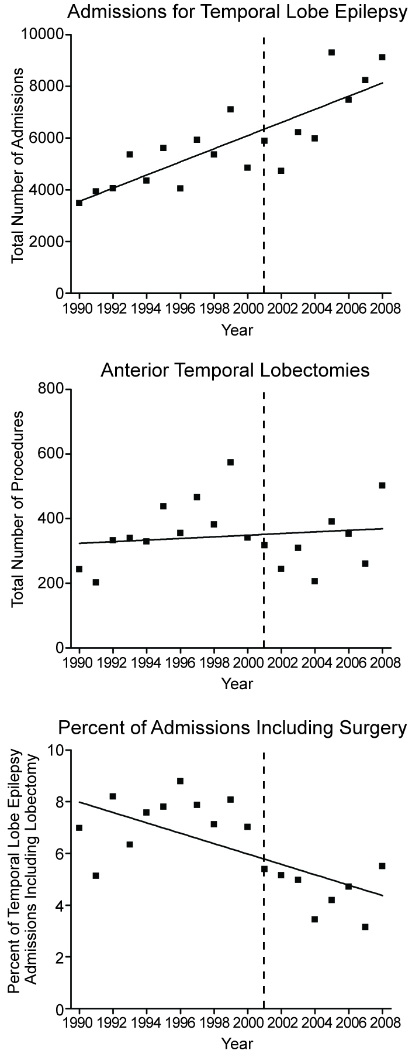
Figure 2.
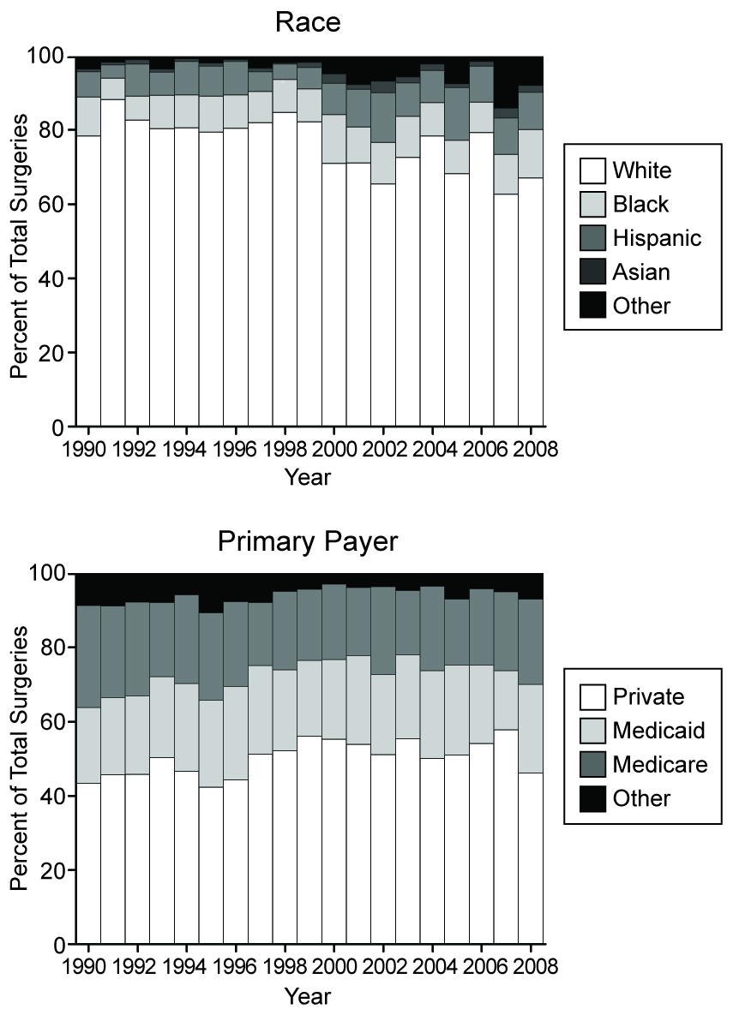
Supplementary eFigure 1.
